1- How many ConfigMaps exist in the environment?

**kubectl get configmaps --all-namespaces**

2- Create a new ConfigMap Use the spec given below.

ConfigName Name: webapp-config-map

Data: APP_COLOR=darkblue

**kubectl create configmap webapp-config-map --from-literal=APP_COLOR=darkblue**

3- Create a webapp-color POD with nginx image and use the created

ConfigMap

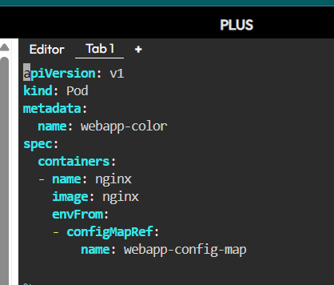

4- How many Secrets exist on the system?

**kubectl get secrets --all-namespaces**

5- How many secrets are defined in the default-token secret?

**kubectl describe secret <default-token-xxxx> -n default**

6- create a POD called db-pod with the image mysql:5.7 then check the

POD status

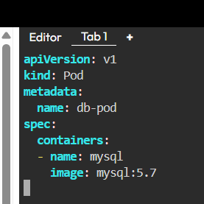

7- why the db-pod status not ready

**Because MySQL requires important environment variables like:**

**MYSQL_ROOT_PASSWORD**

**Without them, the container will fail to start .**

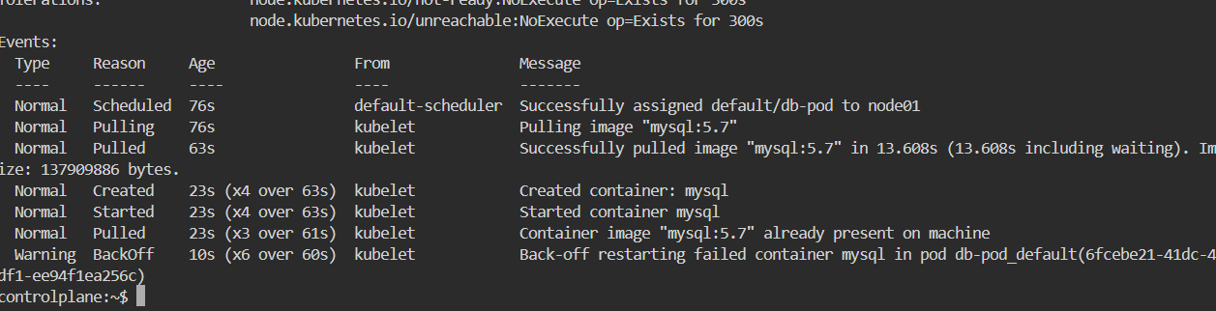

8- Create a new secret named db-secret with the data given below.

Secret Name: db-secret

Secret 1: MYSQL_DATABASE=sql01

Secret 2: MYSQL_USER=user1

Secret3: MYSQL_PASSWORD=password

Secret 4: MYSQL_ROOT_PASSWORD=password123

**kubectl create secret generic db-secret \**

**--from-literal=MYSQL_DATABASE=sql01 \**

**--from-literal=MYSQL_USER=user1 \**

**--from-literal=MYSQL_PASSWORD=password \**

**--from-literal=MYSQL_ROOT_PASSWORD=password123**

9- Configure db-pod to load environment variables from the newly created

secret.

Delete and recreate the pod if required.

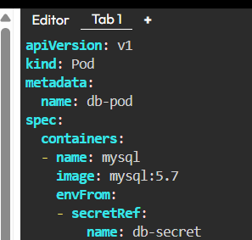

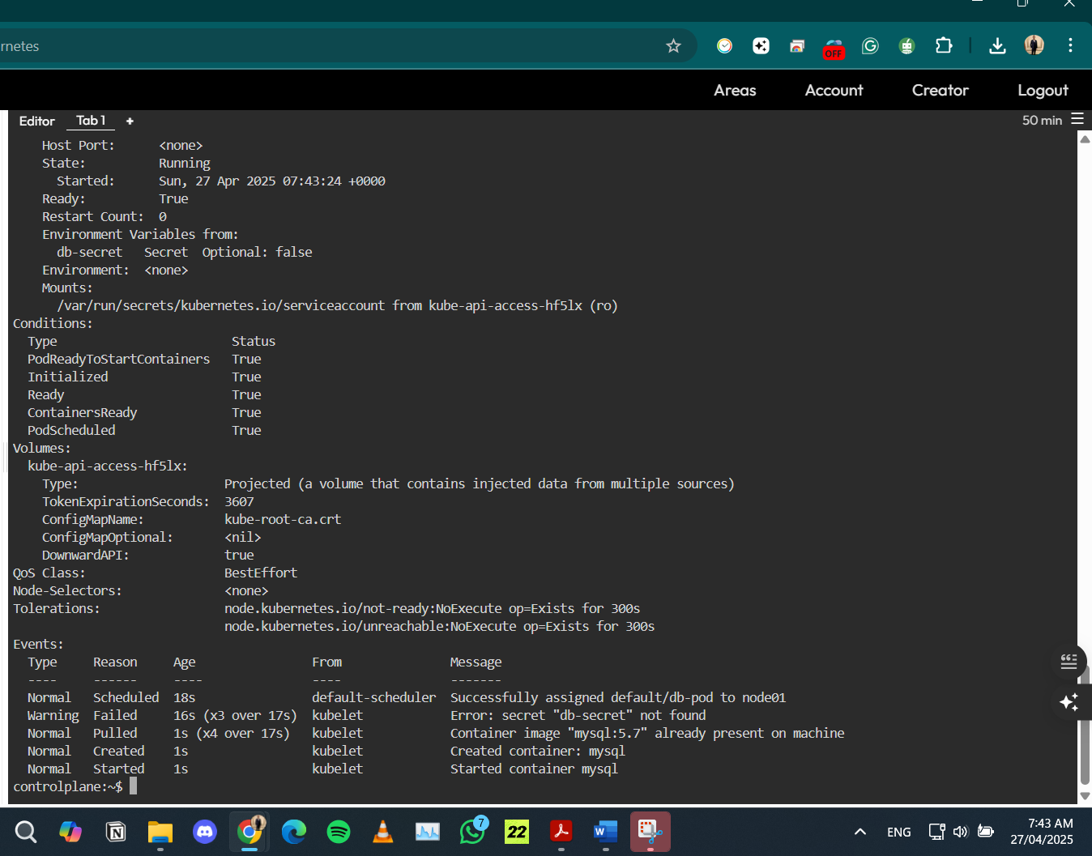

10- Create a multi-container pod with 2 containers.

Name: yellow

Container 1 Name: lemon

Container 1 Image: busybox

Container 2 Name: gold

Container 2 Image: redis

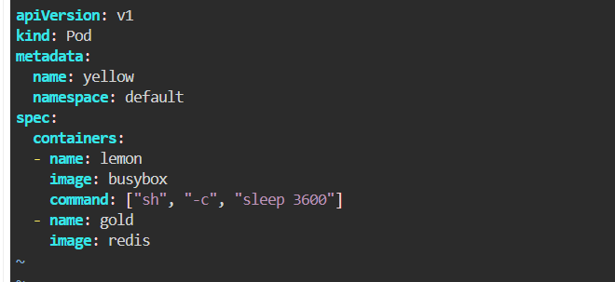

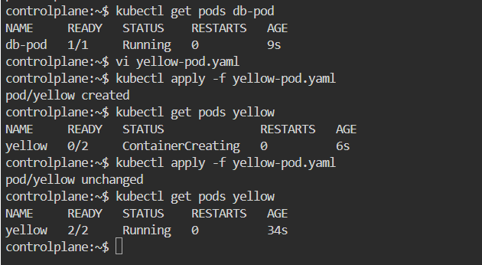

11- Create a pod red with redis image and use an initContainer that

uses the busybox image and sleeps for 20 seconds

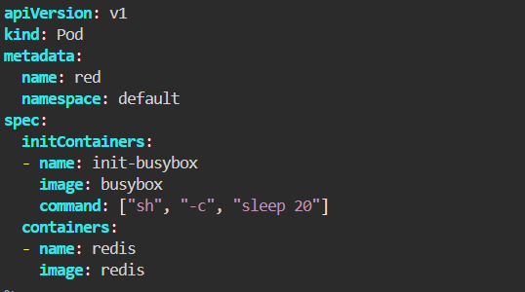

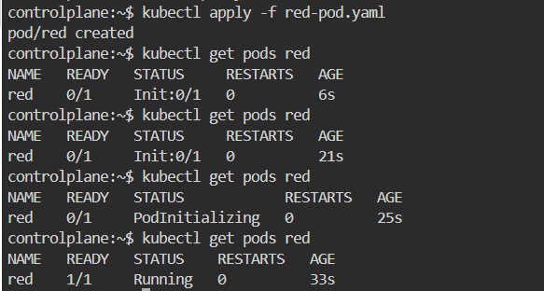

12- Create a pod named print-envars-greeting.

1. Configure spec as, the container name should be

print-env-container and use bash image.

print-env-container and use bash image.

2. Create three environment variables:

a. GREETING and its value should be “Welcome to”

b. COMPANY and its value should be “DevOps”

c. GROUP and its value should be “Industries”

4. Use command to echo ["$(GREETING) $(COMPANY) $(GROUP)"]

message.

5. You can check the output using <kubctl logs -f [ pod-name ]>

command.

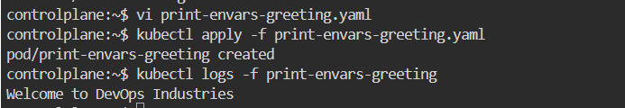

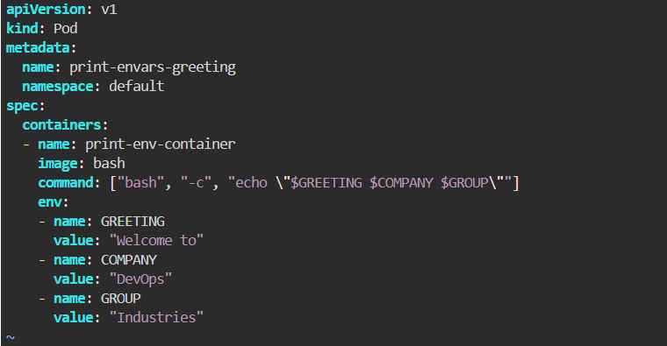

13- Where is the default kubeconfig file located in the current environment?

~/.kube/config

14- How many clusters are defined in the default kubeconfig file?

15- What is the user configured in the current context?



16- Create a Persistent Volume with the given specification.

Volume Name: pv-log

Storage: 100Mi

Access Modes: ReadWriteMany

Host Path: /pv/log

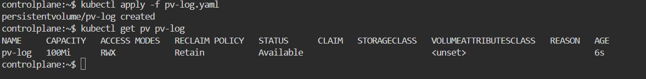

17- Create a Persistent Volume Claim with the given specification.

Volume Name: claim-log-1

Storage Request: 50Mi

Access Modes: ReadWriteMany

18- Create a webapp pod to use the persistent volume claim as its storage.

Name: webapp

Image Name: nginx

Volume: PersistentVolumeClaim=claim-log-1

Volume Mount: /var/log/nginx

